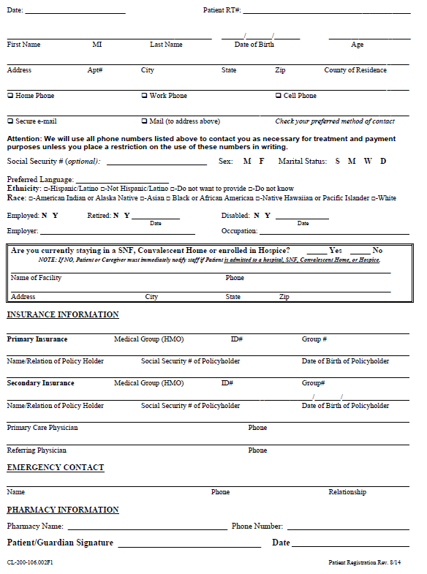

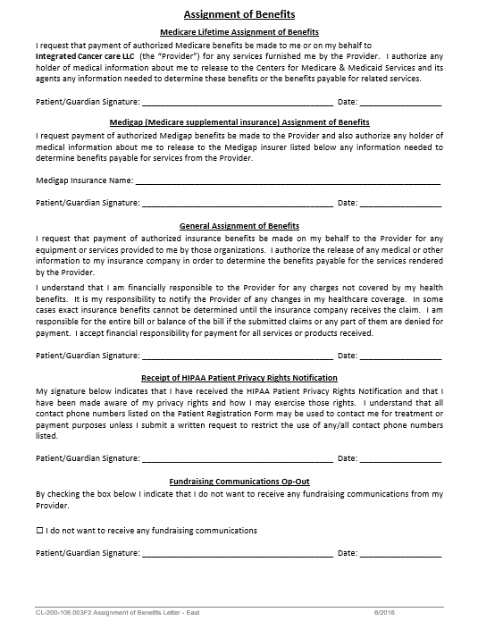

Please mark any of the following problems you have **EVER** been diagnosed with:

|  |  |  |  |  |  |
| --- | --- | --- | --- | --- | --- |
|  | Yes |  | Yes |  | Yes |
| Prior Cancer  Type: ________________ |  | Hernia  Location: _______________ |  | Other skin condition  Type: ________________ |  |
| Angina (Chest Pain) |  | Diverticular Disease |  | Gout |  |
| Heart Attack |  | Hemorrhoids |  | Skin Cancer Type: ________________ |  |
| Heart Failure (CHF) |  | Rectal Bleeding |  | Arthritis |  |
| Irregular Heart Beat |  | Ulcers |  | Asthma |  |
| Heart Murmur |  | Gallbladder disease |  | Chronic Bronchitis/Emphysema (COPD) |  |
| Coronary Artery Disease |  | Liver disease |  | Glaucoma |  |
| High Blood Pressure |  | Crohn’s Disease |  | Cataracts |  |
| High Cholesterol |  | Colitis |  | Anemia |  |
| Stroke |  | Irritable Bowel Syndrome |  | Blood Clots or Clotting Disorder |  |
| Seizures or Epilepsy |  | Kidney Failure |  | Depression |  |
| Parkinson’s Disease |  | Kidney Stones |  | Anxiety |  |
| Multiple Sclerosis |  | Bladder Infections or Cystitis |  | Claustrophobia |  |
| Other Neurological Problem  Type: _______________ |  | Prostatitis |  | Diabetes |  |
| Tuberculosis  Date of diagnosis: _________ |  | BPH/ Enlarged Prostate |  | Other: |  |
| HIV or AIDS |  | Thyroid Disease  Type: ________________ |  | Other: |  |
| Radiation Exposure |  | Cancer Treatment |  |  |  |
| X-Ray Therapy treatments |  | Chemotherapy |  | Caffeine Use |  |
| Radiation Therapy  Location: ______________________  Name of Institution: ______________________ |  | Hormone Therapy  Type: ______________________  Last dose: ______________________ |  | Tobacco Use  ⎕ Current  ⎕ Quit  Year: _____________  Years of  Use: _____________ |  |
| Cobalt, radioactive iodine or other treatments |  |  |  | Alcohol Use |  |

Family History

|  |  |  |  |
| --- | --- | --- | --- |
| Relation | Age | Medical Problems | If deceased, age and cause of death |
| Father |  |  |  |
| Mother |  |  |  |
| Brother(s) |  |  |  |
| Sister(s) |  |  |  |
| Other: |  |  |  |
|  |  |  |  |
|  |  |  |  |
| Family member with:  ⎕ Prostate Cancer  ⎕ Breast Cancer | Comments: |  |  |

Surgical History

|  |  |  |
| --- | --- | --- |
| Surgeries | Where | Year |
|  |  |  |
|  |  |  |
|  |  |  |
|  |  |  |
|  |  |  |
| Last Colonoscopy? |  |  |

Social History

|  |
| --- |
| Work situation: ⎕ Full time ⎕ Part time ⎕ Medical Leave ⎕ Disability ⎕ Retired |
| Living situation: ⎕ House ⎕ Apartment ⎕ Mobile Home Who lives with you? ____________________ |
| Activity: ⎕ Regular Exercise ⎕ Light exercise ⎕ Occasional exercise ⎕ No exercise |
| Transportation: ⎕ Able to drive self ⎕ Driver required |
| Diet: ⎕ Regular ⎕ Vegan/Vegetarian ⎕ Renal ⎕ Diabetic ⎕ Gluten-Free |
| Did you ever work in an occupation that involved exposure to cancer causing chemicals, fumes or other carcinogens? ⎕ Yes ⎕ No If yes, what? _____________________________________________________________________ |
| Did you serve in the military? ⎕ Yes ⎕ No Did you serve overseas? ⎕ Yes ⎕ No |

List any medications you are **CURRENTLY** taking. *Please include over the counter, vitamins and supplements*.

|  |  |  |  |
| --- | --- | --- | --- |
| Medication | Dose | How often do you take it? | Why are you taking it? |
|  |  |  |  |
|  |  |  |  |
|  |  |  |  |
|  |  |  |  |
|  |  |  |  |
|  |  |  |  |
|  |  |  |  |
|  |  |  |  |
|  |  |  |  |
|  |  |  |  |
|  |  |  |  |
|  |  |  |  |
|  |  |  |  |
|  |  |  |  |
|  |  |  |  |
|  |  |  |  |

|  |  |
| --- | --- |
| Allergies |  |
| Do you have allergies to medications? | ⃝ Yes ⃝ No |
| If yes, what are you allergic to? | What happens if you take it? |
|  |  |
|  |  |
|  |  |

Please mark any symptoms you are **CURRENTLY** experiencing:

|  |  |  |  |  |  |
| --- | --- | --- | --- | --- | --- |
| Constitutional | Yes | Gastrointestinal | Yes | Musculoskeletal | Yes |
| Tiredness (Fatigue) |  | Loss of appetite |  | Hip Replacement  ⎕ Left ⎕ Right |  |
| Fever |  | Dark, tarry stools |  | Joint Pain |  |
| Chills |  | Stools with blood |  | Muscle Pain |  |
| Weight Change |  | Abdominal pain |  | Bone Pain |  |
| Night Sweats |  | Nausea/Vomiting |  | Endocrine | Yes |
| Eyes | Yes | Heartburn |  | Excessive thirst |  |
| Blurred Vision |  | Diarrhea |  | Frequent urination |  |
| Double Vision |  | Constipation |  | Cold or heat intolerance |  |
| Blindness |  | Integumentary | Yes | Hematologic/lymphatic | Yes |
| Glasses/Contacts |  | Rash |  | Lymph node enlargement |  |
| Ear, Nose, Mouth and Throat | Yes | Itching |  | Swelling of arms/legs |  |
| Sinus drainage/pressure |  | Abnormal spots or moles |  | Blood clotting problems |  |
| Mouth Sores |  | Neurologic | Yes | Anemia or easy bruising |  |
| Swallowing difficulty |  | Headaches |  | Allergic/immunologic | Yes |
| Changes in voice |  | Confusion |  | Food allergies  Type: ________________ |  |
| Nosebleeds |  | Tremors |  | Environmental allergies  Type: ________________ |  |
| Sore throat |  | Seizures |  | Seasonal allergies |  |
| Ear pain or ringing |  | Strength or sensation deficits |  | Chronic steroid use  Type: ________________ |  |
| Cardiovascular | Yes | Walking disturbance or imbalance |  |  |  |
| Chest Pain |  | Difficulty Sleeping |  | Devices | Yes |
| Dizziness |  | Respiratory | Yes | Pacemaker |  |
| Leg Swelling |  | Shortness of breath |  | Internal Defibrillator |  |
| Fluttering (Palpitations) |  | Congestion |  | Implanted Port |  |
| Shortness of breath when flat |  | Cough |  | Implanted Metal |  |
| Pounding in chest |  | Coughing up blood |  | Other Device: ______________________ |  |

PhysicianList

Please list the names, addresses and phone numbers of physicians that you are seeing. If you do not have all the information with you at the time of your visit, please call us when you get home. This information is very important so that we can inform your physicians of your progress.

|  |  |  |
| --- | --- | --- |
| Physician | Address | Phone Number |
| Primary Physician |  |  |
| Referring Physician |  |  |
| Medical Oncologist |  |  |
| Surgeon |  |  |
| Cardiologist |  |  |
| Endocrinologist |  |  |
| Other Physician (specify) |  |  |

